GangKui Cup
RULEBOOK

I. Schedule & Format

1. Tournament Format
- Tournament Rules: This championship does not offer direct invitations based on VRS List; all participants will be invited on a "first-come, first-served" basis through open registration.
- The tournament consists of 3 stages: Play-In, Group stage and the Playoffs.
- The top 4 registered teams by VRS will be directly seeded into the Main Event (Playoffs).
- Play-In: This stage will be held online. The game server will be hosted in China. The 20 teams will be divided into four groups (A, B, C, and D) and compete in a four round-robin format groups. There will be 5 teams in each group. All matches will be BO1. The top two teams from each group will advance to Group Stage.
- Group Stage: This stage will be held online. A total of eight teams will be divided into two groups of four teams each, competing in a double-elimination format. The Opening and Winners’ matches are BO1, while the Elimination and Decider matches are BO3. The top two teams from each group will advance to the Playoffs.
- Playoffs: This stage will be held offline in Shanghai and will use a double-elimination format. All matches will be BO3.
- The tournament will use the following seven maps: OVERPASS, MIRAGE, INFERNO, DUST2, NUKE, ANCIENT, ANUBIS.
- During Play-In and Group Stage, there will be no coach slot on the server. Coaches may stand behind the players during the match.

2. Schedule
- Play-In Dates: March 26-27, 2026 (Beijing Time)
- Group stage Dates: March 28-29, 2026 (Beijing Time)
- Playoffs Dates: April 1–5, 2026 (Beijing Time)

3. Match Seeding and Pairings
- Play-In Stage (excluding directly invited playoff teams)
Group A
SEED #1
SEED #20
SEED #16
SEED #12
SEED #8
Group B
SEED #2
SEED #19
SEED #15
SEED #11
SEED #7
Group C
SEED #3
SEED #18
SEED #14
SEED #10
SEED #6
Group D
SEED #4
SEED #17
SEED #13
SEED #9
SEED #5
If a team does not have a VRS ranking, the position will be determined by a random draw.
- Group Stage
Seeding will first be determined by match wins, then by VRS ranking.
The first-place teams from each group will be seeded 1–4 based on their VRS ranking.
The second-place teams from each group will be seeded 5–8 based on their VRS ranking.
If none of the teams have a VRS ranking, the seeding will be determined by a random draw.
- Playoffs
The four directly invited teams will be seeded 1–4 according to their VRS ranking.
For teams advancing from the Group Stage, seeding will first be determined by match wins, then by VRS ranking.
The first-place teams from each group will be seeded 5–6 based on their VRS ranking.
The second-place teams from each group will be seeded 7–8 based on their VRS ranking.
If only one of the two teams has a VRS ranking, the team with the VRS ranking will be seeded higher, while the team without a VRS ranking will be seeded lower.
If neither team has a VRS ranking, the seeding will be determined by a random draw.

II. Anti-Cheating Camera Angles
1. During online matches, participants must abide by the principle of fair competition, follow the referee's arrangements, and cooperate with anti-cheating inspections related to the tournament.
2. When specifically stated,each player in an online event must be able to provide a clean camera feed.Every participant needs to activate their camera a minimum of thirty (30) minutes before the start time of the match.Participants may turn off their cameras between maps in a series but must turn them back on a minimum of five (5) minutes before the start of the next map.Failure to provide a clean camera feed for the full duration of the map (including pre-match) will result in the participant being subject to fines.If at any point during the map the camera feed is not provided,it will be considered missing for the entire mapand will also result in a fine.

- If aparticipant fails to fulfil the camera obligations in more than two matches in the same competition,they will be considered a repeat offender and the standard punishments will be increased.
4.For online competitions,players may be required to provide up to two live camera feeds showing their setup-including,but not limited to,their monitor,key board,mouse,and surrounding area.Specific requirements will be communicated on a case-by-casebasis. Compliance with these instructions is mandatory;failure to do so will result in penalties,up to and including disqualification from the competition.
5.The camera must provide a clear view with a correct angle. The required shooting perspective [see figure] is a 45-degree angle from the rear side of each participant. The recorded footage must include the participant's body, screen, mouse, and keyboard. If all five team members are in the same room, one camera/video recorder must be installed at the back; if each player is in a separate room, a camera/video recorder must be equipped behind each player.

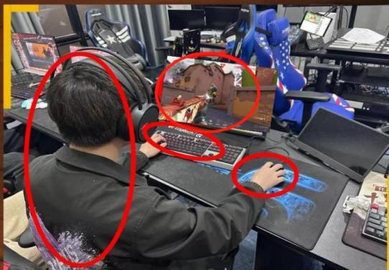
6.Participants shall enter Tencent Meeting or access other websites as required by the event organizer and turn on their cameras.
7.All participants must record the first-person match footage and third-person footage (showing hands, face, and screen) of the match throughout the entire match day. The recordings must be uploaded to Baidu Netdisk and shared with the tournament organizer by 3:00 AM the next day. Only Baidu Netdisk is accepted, and the sharing period must be set to permanent.

III. Player Facial Camera Requirements
1. During the online match stage, players are required to use facial cameras/video recorders.
2. Facial perspective requirements: Frontal or side view with reasonable lighting conditions to clearly capture the player's facial expressions.
3. Participants shall enter Tencent Meeting or access other websites as required by the event organizer and turn on their cameras.


IV. Equipment Requirements

Participants must bring their own peripherals, including mouse, keyboard, mouse pad, and in-ear headphones. The tournament organizer will provide over-ear headphones for sound insulation and microphone communication. The tournament is not responsible for replacing participants' self-provided peripherals in case of malfunctions.

V. Tournament Prize Pool
Total Prize Pool by Team Count
- Less than 16 teams: $10,000 total prize pool
- 17-24 teams: $15,000 total prize pool
- There will be no additional compensation provided to any team or player outside of the prize pool.
Prize Breakdown (%)
- 1st Place: 50% of the total prize pool
- 2nd Place: 25% of the total prize pool
- 3rd Place: 15% of the total prize pool
- 4th Place: 10% of the total prize pool

For other relevant content of this tournament, please refer to the Counter-Strike 2 Tournament RULEBOOK.

